Code Report
- Objective of program : To find the mass of an object when the density varies at every point in the object but at the same time can be expressed as a function of different dimensions considered.
- Some Considerations :
i)When we mean variable density , we mean that along all the three dimensions x,y,z the density is not constant and rather a function of x,y and z.
ii)In terms of integration we can consider the volume to be the smallest volume that we integrate along the boundaries of the object
iii)Variables and the axis involved in this case are independent of each other , that is for example x,y do not bear any relation to z and the same for the other variables involved

- Formula involved :
Mass = density * volume
It can be represented as dV
dV = dx. dy. dz
Mass =integration of [ f(x,y,z) .dV] along the x,y,z boundary of the object
Here f(x,y,z) is the function representing the variable density along x,y and z for the object
And dV = dx. dy. dz
For the case of simplicity I am considering the variable density of the object to be
= [4/(1+x²)]* [4/(1+y²)]* [4/(1+z²)]
I am also going to integrate along the boundary conditions x=0 to 1
y=0 to 1
z=0 to 1
Mass of the object =integration of{ [4/(1+x²)]* [4/(1+y²)]* [4/(1+z²)].dV}
Mass=Integration of{ [4/(1+x²)]* [4/(1+y²)]* [4/(1+z²)].dx.dy.dz} x=0→1 y=0→1 z=0→1
Mass = ...dx.dy.dz
The algorithm in the programs discussed from here on will be to evaluate the
aforementioned triple integral to calculate the mass

- Non-Optimized Code:
Specification
Execution time = 16 sec
Steps to execute : ran on online c compiler
#include<stdio.h>
#include<time.h>
static long num_steps =2000000000;
double step;
int main()
{
clock_t reg_end;
clock_t reg_start=clock();
int i ;
double x,y,z,pi1,pi2,pi3,final_ans;
double sum1=0.0,sum2=0.0,sum3=0.0;
step = 1.0/(double)num_steps;
for (i=0;i<num_steps;i++){ // loop1
x = (i+0.5)*step;//*1
sum1 = sum1 + 4.0/(1+x*x);//possible race condition-1
}
pi1 = step*sum1;
printf("\n pi1->%.2f",pi1);
for(i=0;i<num_steps;i++){ //loop 2
y=(i+0.5)*step;//*2
sum2=sum2+4.0/(1+y*y);//possible race condition-2
}
pi2 = step*sum2;
for(i=0;i<num_steps;i++){ //loop 3
z=(i+0.5)*step;//*3
sum3=sum3+4.0/(1+z*z);//possible race condition-3
}
pi3 = step*sum3;
printf("\n pi3->%.2f",pi3);
final_ans = pi1*pi2*pi3;
printf("\n after integration");
printf("\n integration result->%.2f",final_ans);
reg_end=clock();
printf("\nTime taken->%.2ld",(reg_end-reg_start)/CLOCKS_PER_SEC);
}
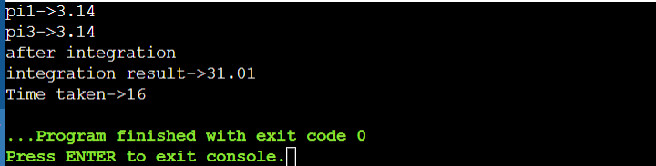

- Area where parallelisation can take place :
loop-1
loop -2
loop-3
Considerations:
When executed in parallel all the threads might write onto the same memory space allocated for the respective sum variable and hence the threads might get serialized by the compiler or worse it will be in a constant state of error since it is a race condition
The first scenario will take a lot of execution time. In second case the program will not run as desired and will throw run time errors
2 ways to mitigate this
*make the sum calculation critical
→So that only 1 thread writes onto it at a given point
→Since the sum calculation is inside for loop , making a statement critical inside for
loop will serialize the threads and will essentially not improve speed up
* apply for loop reduction
→So that every thread writes onto its own copy of the variable and in the end it gets
operated upon based on the operation specified
→If it was ‘+’ operation : initial value =0;
If it was ‘*’ operation : initial value = 1,
If it was logical and operation : initial value = logic 1
If it was logical and operation : initial value = logic 0
→Schedule the reduction
* static = divide the number of iterations to be handled by a single thread
* dynamic = assign iteration to thread based on availability
* guided

- Parallelized Code:
Specification
Execution time : 7 sec
Steps to execute : ran on online c compiler
Compiler flags set : -fopenmp
#include<stdio.h>
#include<time.h>
#include<omp.h>
static long num_steps =2000000000;
double step;
void parallelizedCode(double pi,double step)
{
int i,id;
double x,sum;
omp_set_num_threads(8);
#pragma omp parallel
{
id = omp_get_thread_num();
printf("\n id->%d",id);
int numThreads = omp_get_num_threads();
sum=0.0;
#pragma omp parallel for schedule(static,10000) reduction(+:sum) reduction(*:x)
for(i=id;i<num_steps;i=i+numThreads)
{
x=(i+0.5)*step;
sum=sum+4.0/(1+x*x);
}
pi+=sum*step;
}
printf("\n Integration result->%.2f",pi*pi*pi);
}
int main()
{
double pi=0.0,step=1/(double)num_steps;
clock_t reg_end;
clock_t reg_start;
reg_start=clock();
parallelizedCode(pi,step);
reg_end=clock();
printf("\n Time taken->%.2ld",(reg_end-reg_start)/CLOCKS_PER_SEC);
}

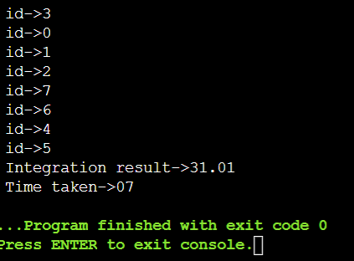
- Remarks for reduction on x for the optimized code :
→When x is treated as a private variable and assigned individually to every thread in an
iteration rather than working on a shared copy there is more parallelisation.
→When operated on the shared variable every thread waited to write on the value of x ,
but when declared as a part of reduction , now every thread gets its own copy and the
speedup is hence better.
→This part was indicated as 1* , 2* and 3* in the non-optimized code

- Combined code:
Specification:
Steps to execute : ran on online c compiler
Compiler flags set : -fopenmp
Ratio of non-optimized and optimized code execution time: 2
#include<time.h>
#include<omp.h>
#include<stdio.h>
static long num_steps =2000000000;
double step;
clock_t reg_end;
clock_t reg_start;
double speedup = 1.0;
void regularCode(double pi,double step)
{
double pi1=pi;
double pi2=pi;
double pi3=pi;
reg_start=clock();
int i ;
double x,y,z,final_ans;
double sum1=0.0,sum2=0.0,sum3=0.0;
step = 1.0/(double)num_steps;
for (i=0;i<num_steps;i++){
x = (i+0.5)*step;
sum1 = sum1 + 4.0/(1+x*x);
}
pi1 = step*sum1;
printf("\n pi1->%.2f",pi1);
for(i=0;i<num_steps;i++){
y=(i+0.5)*step;
sum2=sum2+4.0/(1+y*y);
}
pi2 = step*sum2;
for(i=0;i<num_steps;i++){
z=(i+0.5)*step;
sum3=sum3+4.0/(1+z*z);
}
pi3 = step*sum3;
final_ans = pi1*pi2*pi3;
printf("\n integration result->%.2f",final_ans);
reg_end=clock();
printf("\n Time taken in regular code->%.2ld",(reg_end-reg_start)/CLOCKS_PER_SEC);
speedup = speedup*((reg_end-reg_start)/CLOCKS_PER_SEC);
}
void parallelizedCode(double pi,double step)
{
int i,id;
double x,sum;
omp_set_num_threads(8);
reg_start=clock();
#pragma omp parallel
{
id = omp_get_thread_num();
printf("\n id->%d",id);
int numThreads = omp_get_num_threads();
sum=0.0;
#pragma omp parallel for schedule(static,10000) reduction(+:sum) reduction(*:x)
for(i=id;i<num_steps;i=i+numThreads)
{
x=(i+0.5)*step;
sum=sum+4.0/(1+x*x);
}
pi+=sum*step;
}
printf("\n Integration result->%.2f",pi*pi*pi);
reg_end=clock();
printf("\n Time taken in || code->%.2ld",(reg_end-reg_start)/CLOCKS_PER_SEC);
speedup = speedup/((reg_end-reg_start)/CLOCKS_PER_SEC);
}
int main()
{
double pi=0.0,step=1/(double)num_steps;
regularCode(pi,step);
printf("\n");
parallelizedCode(pi,step);
printf("\n speedup->%.2f",speedup);
}
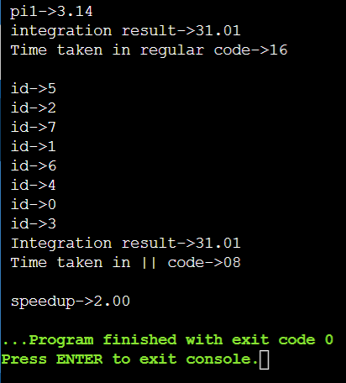

- Observations
Experimenting against thread number and scheduling method to find speed up
No of threads | Static schedule with chunk size | Dynamic Schedule | auto | guided | Speed up
8 | 10000 | - | - | - | 2.00
8 | 20000 | - | - | - | 2.29
8 | - | - | yes | - | 2.00
8 | - | yes | - | - | 0.33(no speed up)
8 | - | - | - | yes | 2.29
16 | 10000 | - | - | - | 2.00
16 | 20000 | - | - | - | 2.29
16 | - | - | yes | - | 2.12
16 | - | yes | - | - | 0.33(no speed up)
16 | - | - | - | yes | 2.12

- Learning outcomes :
→OpenMP
→Loop scheduling
→Parallelising in SPMD rather than SIMD
- References:
https://www.openmp.org/wp-content/uploads/SC17-Kale-LoopSchedforOMP_BoothTalk.pdf
http://www.inf.ufsc.br/~bosco.sobral/ensino/ine5645/OpenMP_Dynamic_Scheduling.pdf
https://www.openmp.org/wp-content/uploads/OpenMP-API-Specification-5-2.pdf

